NEWS RELEASE
U.S. Dept. of Agriculture
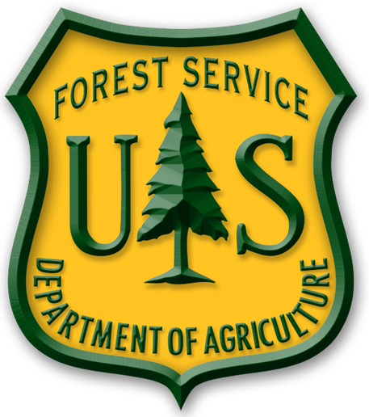
U.S. Forest Service
Coconino National Forest
www.fs.fed.us/r3/coconino
www.twitter.com/CoconinoNF
www.flickr.com/photos/coconinonationalforest

For Immediate Release
July 27, 2012

Contact: Candice Mark
Tel: 928-203-2900

Smokey Bear and Live Snakes!

Sedona, AZ – The Forest Service welcomes the community and visitors alike to come participate in our upcoming Red Rock Ranger Station interpretive programs.

August 11- We will be celebrating Smokey Bear’s 68th Birthday with a special appearance by Smokey Bear between 11am and 2pm at the Red Rock Visitor Center.
(Also stop by the Red Rock Visitor Center August 9th and 10th to sign Smokey Bear’s birthday card).

August 25 & 26-We will host the very popular Live Snakes of Arizona exhibit with presenters Russell Dunn and Karen McClelland. Come by between 9am and 4 pm at the Red Rock Visitor Center.

The Red Rock Visitor Center is located one mile south of the Village of Oak Creek along State Route 179. For more information, please call the Red Rock Ranger District at (928) 203-2900 or go to www.redrockcountry.org.

###

