KENNEDY SPACE CENTER

SHUTTLE & PAYLOAD PROCESSING STATUS REPORT
Friday, September 27, 2002 (1:00 p.m.)

NOTE: Visit http://www-pao.ksc.nasa.gov/kscpao/schedule/schedule.htm on the KSC Home Page for the latest schedule of future Shuttle missions. For the latest Shuttle status visit http://www-pao.ksc.nasa.gov/kscpao/status/stsstat/current.htm

MISSION STS-112 -- 15TH ISS FLIGHT (9A) – S1 Truss Segment
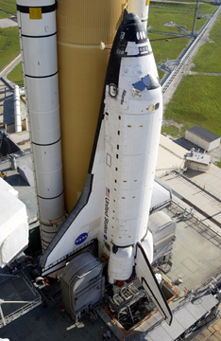
VEHICLE: Atlantis/OV-104
TARGET LAUNCH DATE: Oct. 2, 2002 NET
TARGET LAUNCH PERIOD: 2 – 6 p.m. EDT
TARGET LANDING DATE: Oct. 13, 2002
MISSION DURATION: 11 days
CREW: Ashby, Melroy, Wolf, Sellers, Magnus, Yurchikhin
ORBITAL ALTITUDE AND INCLINATION: 122 nautical miles, 51.6 degrees
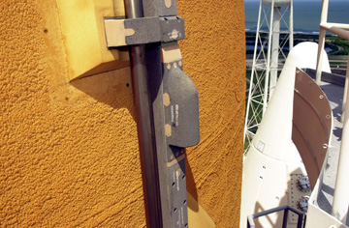
Shuttle Processing Note: Final preparations for next week’s launch of Space Shuttle Atlantis to the International Space Station continue on schedule. Launch countdown preparations continue today following the completion of aft compartment closeouts, door installation and confidence checks.
Final electrical checks of the External Tank camera are also being conducted today.
Mission managers continue to monitor tropical developments though no impacts are expected in the KSC vicinity in the near term and no work is being held up as we proceed on schedule for launch.

MISSION: STS-113 – 16th ISS Flight (11A) – P1 Truss Segment

VEHICLE: Endeavour/OV-105
TARGET LAUNCH DATE: Nov. 10, 2002 NET
TARGET LANDING DATE: Nov. 20, 2002
MISSION DURATION: 11 days

CREW: Wetherbee, Lockhart, Lopez-Alegria, Herrington; (ISS up) Bowersox, Budarin, Pettit; (ISS down) Korzun, Whitson, Treschev
ORBITAL INSERTION ALTITUDE AND INCLINATION: 122 nautical miles/51.6 degrees

Shuttle Processing Note: Preparations are in work to begin final preparations for the upcoming launch to the International Space Station in November. Orbiter jackdown and center of gravity checks are complete. The orbiter is scheduled to be mated to the transporter later today.

MISSION STS-107 –SPACEHAB/ FREESTAR MICROGRAVITY RESEARCH MISSION

VEHICLE – Columbia/OV-102
TARGET LAUNCH DATE: Jan. 16, 2003 NET
TARGET LANDING DATE: Feb. 1, 2003
MISSION DURATION: 16 days
CREW: Husband, McCool, Anderson, Chawla, Brown, Clark, Ramon
ORBITAL INSERTION ALTITUDE AND INCLINATION: 150 nautical miles/39 degrees

Shuttle Processing Note: Columbia continues processing in preparation for its research mission scheduled for no earlier than Jan. 16. Orbital maneuvering system pod functional checks are in work. The payload bay doors were closed yesterday and flow liner weld certifications continue.

ORBITER MAJOR MODIFICATION PERIOD

VEHICLE: Discovery/OV-103

Shuttle Processing Note: The Orbiter Major Modification (OMM) period for Discovery is underway with radiator removal and nose landing gear retraction. Wire inspections continue and will be performed throughout the entire vehicle during the OMM.

-- end --

