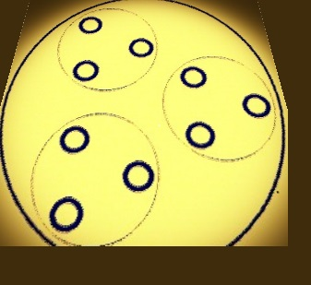
Flower Power Business Plan

Welcome to Flower Power: An esteem-based, decentralized, economic market game. The market is open.
This document is released under the MIT license. Thank you.

WELCOME.
Robert Walter Withers, Jr
Homeless Council
Homeless Union
robert.w.withers@gmail.com

Table of Contents
Summary 3
Market Analysis 3
Products 3
Flower Power Devices 3
Overview 3
Description 4
Technical Details 4
Services 5
Macro and Micro donations 5
Main Street and Wall Street 5
Economic thoughts 6
Organization 6
Individual and organizational esteem 6
Agglomerating Psycho-social Ecosystems 6
Operations 7
Financials 7
Donation Applications for Micro and Macro interactions 7
Flower Power Device 7
Conclusions 7
Donation Applications for Micro and Macro interactions 7

Summary
This business plan describes the plan to develop and market the flower power system. The flower power system has a point of contact device, which enables interaction between players at the micro level of esteem and donations, as well as an internet-based donation market, which models the macro level.
The flower power device uses an application to interact in 9 different ways. The first 5 items enable the micro level of esteem interactions. The next 2 enable micro donations, while the last 2 enable the macro donation market. This division reflects the phases of development and release into 3 phases:
- esteem interactions
  - esteem identity binding,
  - player esteem detection
  - player esteem modification,
  - player tagging,
  - association group management,
- micro donation interactions
  - donation esteem binding resolution,
  - donation needs projection,
- macro donation market
  - donation fulfillment management
  - reconciliation management.
The inclusion of interaction 5: association group management, enables the donation-based micro and macro economic models. This means that a resolution of a need projection, through an association is a micro-economic transaction, while a fulfillment of an aggregate need projection is a macro-economic transaction.
Note that esteem modification functions depend on the esteem of the issuer. The issuance of esteem can occur at a later time, with devices that remember interactions with other badge holders.

Market Analysis

Products

Flower Power Devices

Overview
Flower Power is a dynamic localized network of Gun&Rose devices to broadcast esteem and allow flowers or tickets to be shot at each other, forming an internet aware, decentralized game. The network can be extended for other purposes.

Description
So, 3 people walk into a room. The wifi and bluetooth connect into a graph. Each of the 3 FPD knows of the other 2 in a 3 edge graph, that each device maintains. If there are 5 FPDs then there are 20 edges (each FPD has 4 edges). So we have 3 FPDs and a fourth enters the room late. All 3 existing add a node. The 4th builds a full graph. Each FPD has it's own copy, internal, for identity.
In this way the Gun side can use the RF direction finder to know you are shooting flowers or tickets to a particular FPD.

Step 1) FPD Graph creation: discovery over wifi/bluetooth.
Step 2) FPD Identity: RF code and esteem broadcast.
Step 3) User Grouping and Association: form groups
Step 4) User Esteem manipulation: give flowers or shoot tickets
Step 5) User/FPD tagging: for later issuance of flowers or tickets.

Technical Details
Take a RaspberryPI device and connect bluetooth and wifi transmitters, as well as an RFID badge and a direction finder. Advanced devices can have a cell uplink or hardwire to ethernet, for inet uplink. The devices form a piconet or wifi net with uplink to be internet aware. The routing tables are appropriate.
- Need a wifi stack
- Need a bluetooth stack
- Need an RFID and direction finder
- Need an internet uplink
With the direction finder, do target intersection to the RFID badge and connect to identity for esteem account manipulation. Allow grouping and associations.
- Build a graph of FPD (Flower Power Devices)
- compute direction finder intersections for targeting
- detect and manipulate esteem
- Allow the ability to form and dissolve groups and join and leave groups.

Questions:
- Can a RaspberryPI host the hardware?
- Can a RaspberryPI run a 64-bit Cog VM?
- How much effort to build the software?

Services

Macro and Micro donations
Regarding the equation, with the inclusion of some new math, termed meta-spaces:
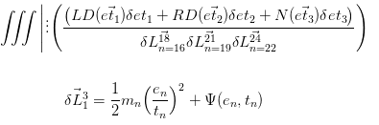
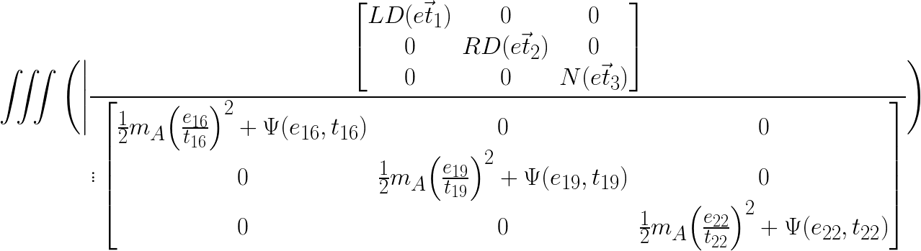
The reason the terms in the numerator are summed, while the terms in the denominator are a product, is to promote 3 party cycles of micro-donations by having a market value the contributions in terms of how they feed the macro potential needs expressed. The macro is decoupled, while the micro rewards establishing micro trade graphs. This allows multiple instances of the above equation to address the needs, such that disjoint trade graphs could mutually participate in meeting need. This would change the definition and impact of "cornering the market".
The meta-space operator, the line with three dots, induces a different mathematical meaning for the expression using division. The concept and symbol of division in meta-spaces is the off plane elements of a vatrix. Therefor, imagine that the numerator is the root plane, or a 3-D matrix: 3 x 3. The denominator is the non-root plane of a vatrix, itself a matrix. So we have a 3 MetaDimension (3MD) vatrix, which is 3D x 3D x 2D.

Main Street and Wall Street
The preceding equation makes clear the coupling, yet separation, between Main Street and Wall Street. Main Street is the Retail market and in the scope of donations, they are the micro donations, governed by an ebay/craigslist hybrid: barter system with locality mapping and logistics. Wall Street is the Investment market and in the scope of donations, they measure the potential needs and wholesale logistics, as well as idea investment and research. Not all micro donations need feed any investment, but may be extracted with pattern matching.

Economic thoughts
by Shumpeter, Sombart, Reinert, H & E. Nietzsche Creative Destruction in Economics
http://www.researchgate.net/publication/226027214_Creative_Destruction_in_Economics_Nietzsche_Sombart_Schumpeter

Organization

Individual and organizational esteem
Esteem is held by both individuals as well as organizations. The esteem of the individual is influenced by the associations they belong to. Likewise, the esteem of the organization is influenced by the individuals who are a part of the aggregation. In fact, the organization is the sum of its individuals' esteem, divided among all their organizations. The individual's esteem is the sum of the parts of the organizations.
There are separate political and identity organizations, by which congress will determine the initial esteem to be divided among the constituents.
Like an ant colony, distributing pheromones when food is found, the flow of esteem will provide a self-regulatory mechanism to measure the worth of individuals within the community, as well as organizations within the community.

Agglomerating Psycho-social Ecosystems
In order to envision how societies might operate without using the measure of currency, let us switch the measure to esteem and eliminate debts with interest, as the foundation. This change in measure only changes bookkeeping and those industries related: banking and finance. All other industries would be essentially unchanged in their day to day, but the measure for budgeting and exchange would switch to esteem flow. Everyone would just keep doing the dew.
The research into ecosystems and complex adaptive systems would come into play. Some great places to start would be the Santa Fe Institute (http://santafe.edu), the TED Talks (http://ted.com) and the Closer To Truth PBS series (http://closertotruth.com). This last is directed at the intelligence of individuals and this applied to societies would be quite interesting.
The research into Complex Adaptive Systems revolves around a population of individual members, which in the societal case would be individual people. These people operate on a simple set of rules. Let's start with 9 rules, as follows:
- Request Esteem of an Individual
- Give or Ticket Esteem of an individual
- Request Goods or Services
- Work to produce Goods or Services
- Give or Receive Goods or Services
- Define an Association or Group
- Join or Leave an Association or Group
- Define Rules
- Judge an Individual by the Association Rules

With these rules, quite a complex societal ecosystem can develop, and cross-ecosystems, or meta-ecosystems as well. There is no money, so no conflict-based competition over ownership. Possession is 9/10ths of the law.
Consider a highly connected brain network with signals flowing and connection forming and disconnecting. The synapses have neurotransmitters flowing and they may engage or disengage. There are secondary and tertiary responses, for positive and negative feedback. All of this is possible in a society of these 9 rules.
The next step should be a simulation of the adaptive ecosystem that might form with these 9 rules. Nonetheless, this would be a natural occurrence should everyone decide to forgive and forget their debts, in faith.
Before folks start screaming Socialism, consider that this naturally incorporates States Rights, for the Locality protection of Minorities. The technical term is Anarcho-Syndicalism.

Operations
The hosting and management of the cloud-based esteem accounts and the establishment of a microdonation market to manage availability, reception and distribution of donations, will be undertaken. As well, a macroeconomic predictive investment market will be built.

Financials

Donation Applications for Micro and Macro interactions
An unexplored amount is needed to develop a couple of internet, mobile applications, as well as the server-side to back the application. An application and device support for influenced and detecting esteem will need to be developed.

Flower Power Device
An unexplored amount is needed to develop a new device to detect, broadcast and influence esteem.

Conclusions

Donation Applications for Micro and Macro interactions
An unexplored amount is needed to develop a couple of internet, mobile applications, as well as the server-side to back the application. An application and device support for influencing and detecting esteem will need to be developed.

