Host file contents:

# Copyright (c) 1993-1999 Microsoft Corp.
#
# This is a sample HOSTS file used by Microsoft TCP/IP for Windows.
#
# This file contains the mappings of IP addresses to host names. Each
# entry should be kept on an individual line. The IP address should
# be placed in the first column followed by the corresponding host name.
# The IP address and the host name should be separated by at least one
# space.
#
# Additionally, comments (such as these) may be inserted on individual
# lines or following the machine name denoted by a '#' symbol.
#
# For example:
#
# 102.54.94.97 rhino.acme.com # source server
# 38.25.63.10 x.acme.com # x client host
#
127.0.0.1 localhost michaelsrogers.com www.michaelsrogers.com
10.0.0.115 michaelsrogers.com www.michaelsrogers.com

Nutopia Modem

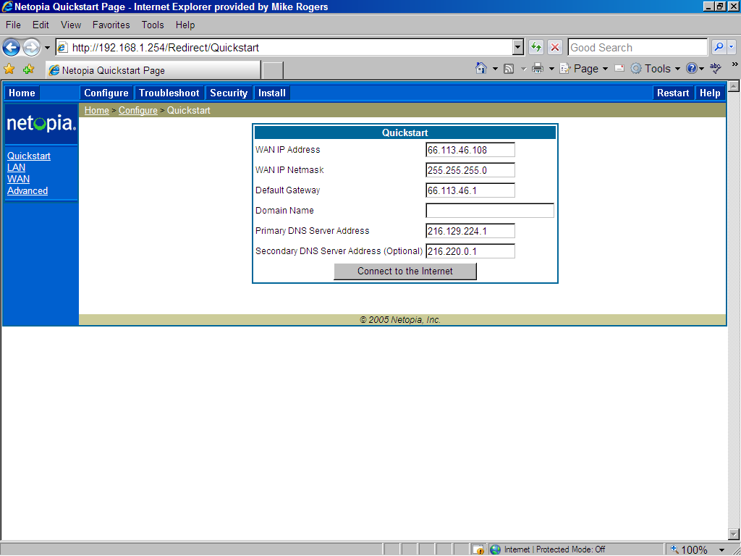

Linksys Router

Upper half of the setup page:

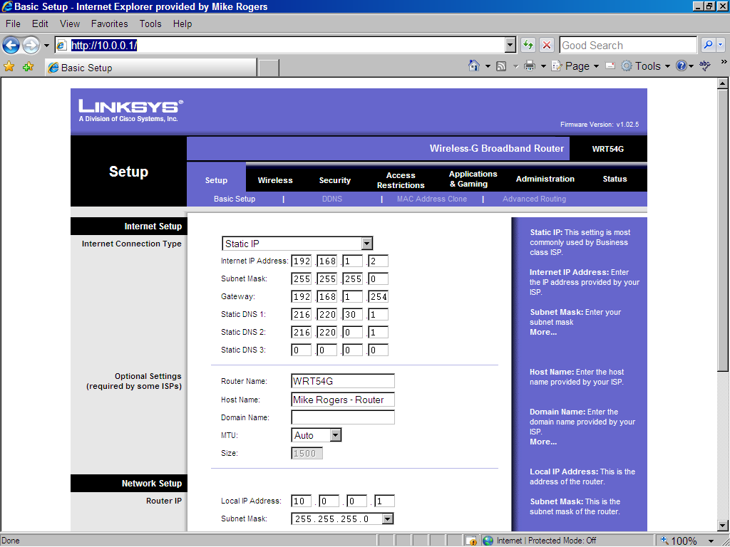

Lower half of the setup page:

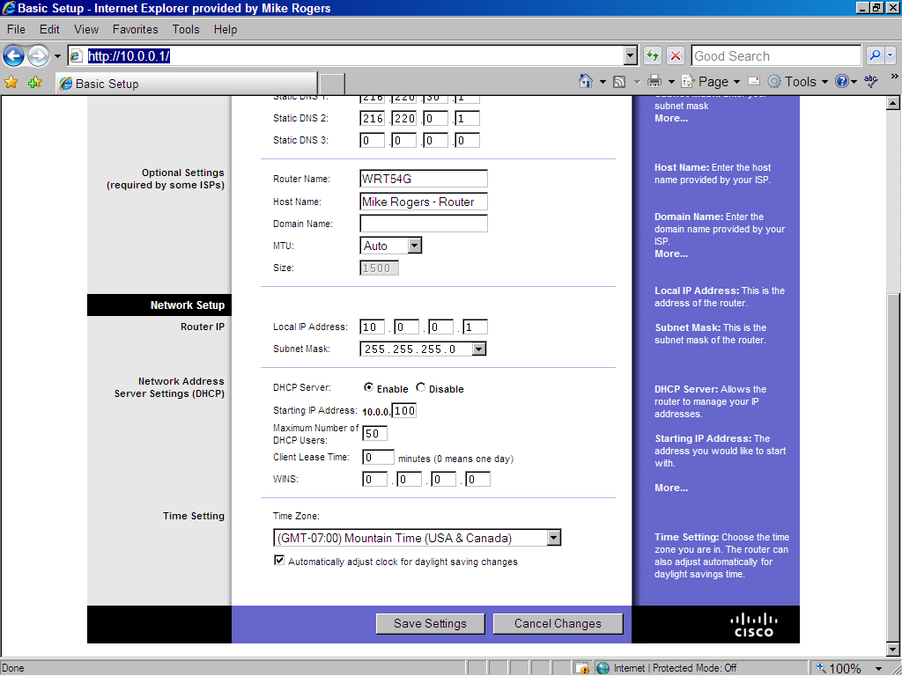

Advanced Routing page of the Linksys Router:

