1. When I access through Apache server. I need the file name to be as below.

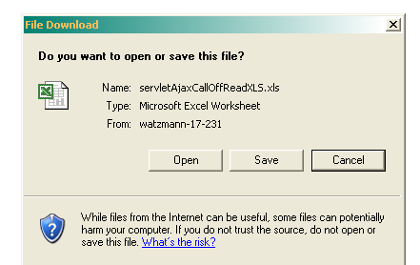

2. When I access through weblogic server

